**Experiment 4**

**Student Name:** Sahil Kaundal **UID:** 21BCS8197

**Branch:** CSE (Lateral Entry)  **Section/Group:** 616/A

**Semester:** 6th **Date of Performance:** 02/03/2023

**Subject Name:** Mobile Application Development Lab **Subject Code:** 20CSP-356

1. **Aim:**

**Creating Application by Using Url.**

1. **Objective:**

**Understanding and analyze the specific requirement, possibilities and challenges when developing for a mobile application context.**

1. **System Requirements:**

* Microsoft Windows 7/8/10 (32-bit or 64-bit)
* 4 GB RAM minimum, 8 GB RAM recommended (plus 1 GB for the Android Emulator)
* 2 GB of available disk space minimum, 4 GB recommended (500 MB for IDE plus 1.5 GB for Android SDK and emulator system image)
* 1280 x 800 minimum screen resolution
* Java JDK5 or later version
* Java Runtime Environment (JRE) 6 Android Studio

1. **Steps/Program:**

**activity_main.xml**

<?xml version="1.0" encoding="utf-8"?>

<androidx.constraintlayout.widget.ConstraintLayout xmlns:android="http://schemas.android.com/apk/res/android"

xmlns:app="http://schemas.android.com/apk/res-auto"

xmlns:tools="http://schemas.android.com/tools"

android:layout_width="match_parent"

android:layout_height="match_parent"

tools:context=".MainActivity"

android:background="@drawable/gradient_background">

<TextView

android:id="@+id/surprise"

android:layout_width="250sp"

android:layout_height="50sp"

android:layout_marginBottom="200dp"

android:text="@string/magic_happens"

android:textAlignment="center"

android:textColor="#F0F62F"

android:textSize="30sp"

android:textStyle="bold|italic"

app:layout_constraintBottom_toTopOf="@+id/youtube"

app:layout_constraintEnd_toEndOf="parent"

app:layout_constraintStart_toStartOf="parent"

app:layout_constraintTop_toTopOf="parent"

app:layout_constraintVertical_bias="0.939"

tools:ignore="TextSizeCheck" />

<Button

android:id="@+id/youtube"

android:layout_width="150sp"

android:layout_height="60sp"

android:layout_marginBottom="170dp"

android:backgroundTint="#DA4B3E"

android:text="@string/youtube"

android:textColor="#A9F6ED"

android:textSize="20sp"

android:textStyle="bold|italic"

app:layout_constraintBottom_toBottomOf="parent"

app:layout_constraintEnd_toEndOf="parent"

app:layout_constraintStart_toStartOf="parent" />

<ImageView

android:id="@+id/facebook"

android:layout_width="65sp"

android:layout_height="57sp"

android:layout_marginBottom="50sp"

app:layout_constraintBottom_toTopOf="@+id/youtube"

app:layout_constraintEnd_toEndOf="parent"

app:layout_constraintStart_toStartOf="parent"

app:srcCompat="@drawable/download"

tools:ignore="ContentDescription" />

<ImageView

android:id="@+id/instagram"

android:layout_width="96sp"

android:layout_height="64sp"

android:layout_marginBottom="45sp"

app:layout_constraintBottom_toBottomOf="parent"

app:layout_constraintEnd_toEndOf="parent"

app:layout_constraintStart_toStartOf="parent"

app:srcCompat="@drawable/download__1_"

tools:ignore="ContentDescription" />

</androidx.constraintlayout.widget.ConstraintLayout>

**MainActivity.java**

package com.example.practical_4;

import android.content.Intent;

import android.net.Uri;

import android.os.Bundle;

import android.widget.Button;

import android.widget.ImageView;

import android.widget.TextView;

import androidx.appcompat.app.AppCompatActivity

public class MainActivity extends AppCompatActivity {

Button youtube;

TextView surprise;

ImageView facebook;

ImageView instagram;

@Override

protected void onCreate(Bundle savedInstanceState) {

super.onCreate(savedInstanceState);

setContentView(R.layout.activity_main);

youtube = findViewById(R.id.youtube);

surprise = findViewById(R.id.surprise);

facebook = findViewById(R.id.facebook);

instagram = findViewById(R.id.instagram)

youtube.setOnClickListener(view -> gotoUrl("https://www.youtube.com/"));

surprise.setOnClickListener(view -> gotoUrl("https://gifer.com/en/gifs/surprise"));

facebook.setOnClickListener(view -> gotoUrl("https://www.facebook.com/"));

instagram.setOnClickListener(view -> gotoUrl("https://www.instagram.com/"));

}

public void openActivity2(){

Intent intent = new Intent(this, Activity2.class);

startActivity(intent);

}

private void gotoUrl(String s) {

Uri uri = Uri.parse(s);

startActivity(new Intent(Intent.ACTION_VIEW,uri));

} }

1. **Result/Output:**

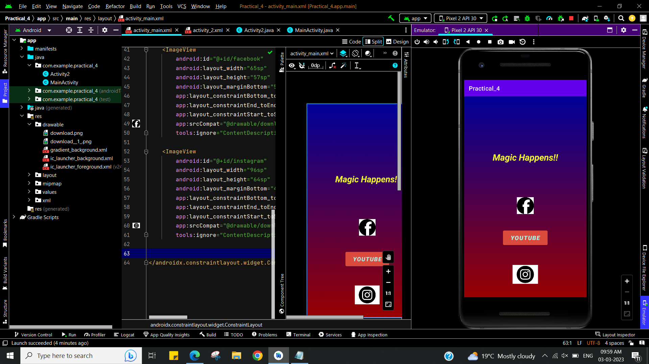

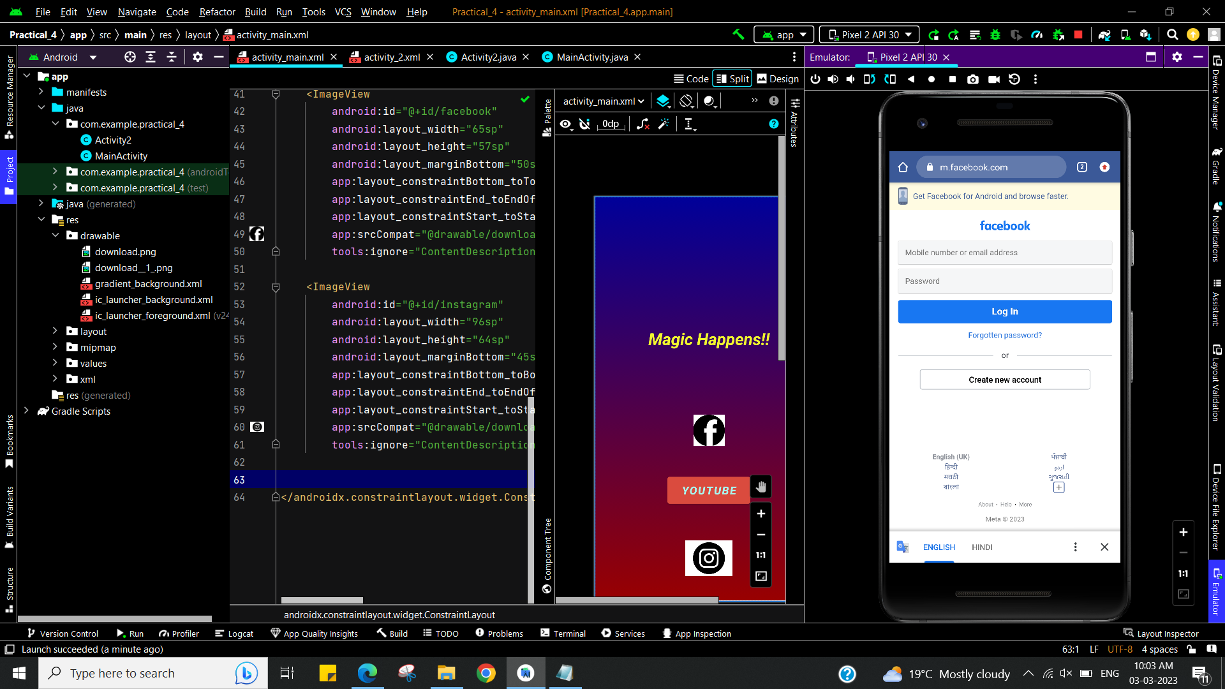

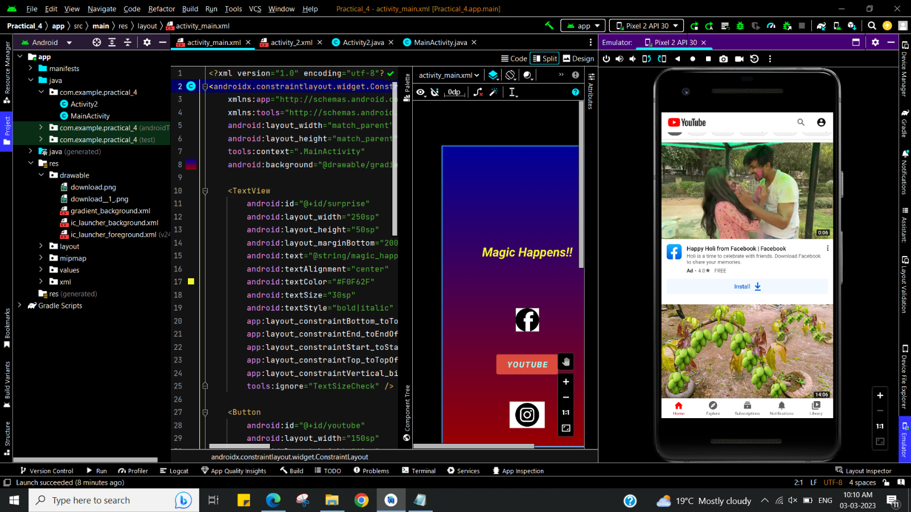

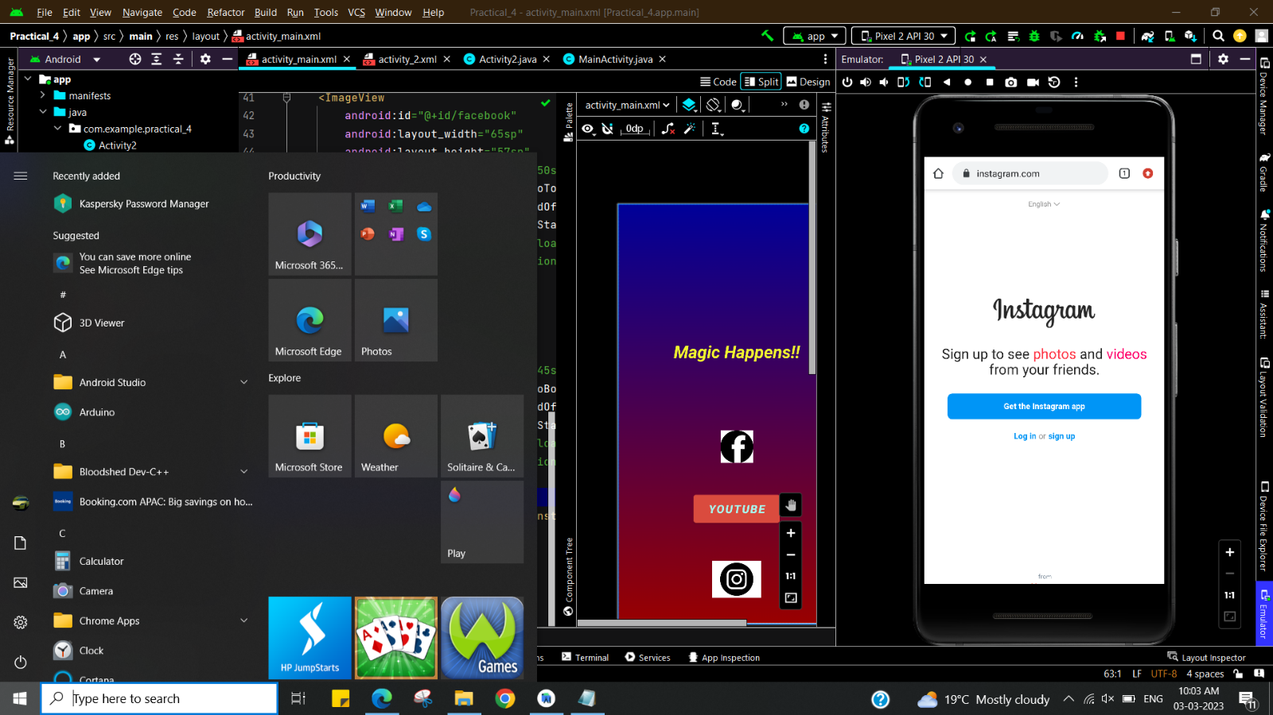

**Learning outcomes (What I have learnt):**

* To design an android application which uses widget in android studio.
* Learnt about running application on android studio.
* **Creating Application by Using Url.**

**Evaluation Grid (To be created as per the SOP and Assessment guidelines by the faculty):**

|  |  |  |  |
| --- | --- | --- | --- |
| Sr. No. | Parameters | Marks Obtained | Maximum Marks |
| 1. |  |  |  |